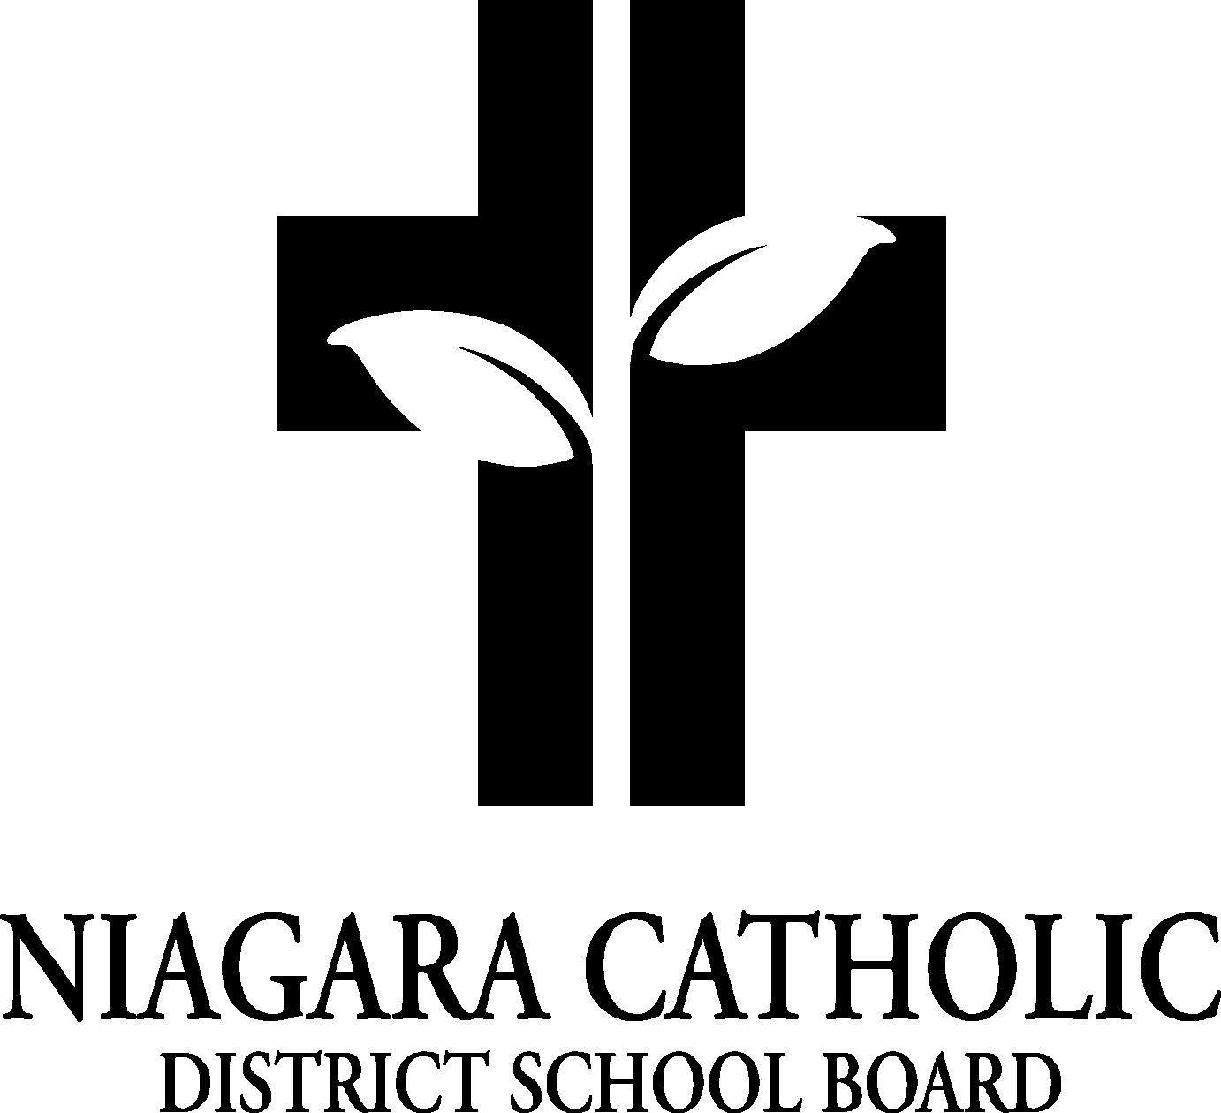

MINUTES OF THE
ST. PETER CATHOLIC SCHOOL COUNCIL MEETING

September 19, 2023
St. Peter School Library

Minutes of the Meeting of the St. Peter Catholic School Council, held on September 19th at 6:00 pm.

The meeting was called to order at 6:00 pm by Chair Candice Foley

A. ROUTINE MATTERS

1. Opening Prayer

The opening prayer was led by Kevin Lamb

2. Roll Call

CATHOLIC SCHOOL COUNCIL MEMBERSHIP |  | Present | Excused | Absent
Principal/Vice-Principal  Secretary/Treasurer | Kevin Lamb | X
Chair | Candice Foley
Co-Chair(s)
Teacher Representative | Linda D’Addario |  |  | X
Non-Teaching Representative | Rita Colling | X
Student Representative
Parish Representative | Father Greg |  |  | X
OAPCE Representative
PARENT/GUARDIAN MEMBERS
Marcie Mlot Styger |  | X
Kathleen O’Connell |  |  | X
Jeff Inch |  | X
Kelly Krause |  | X
Lisa Uglini |  | X
Barbara Gras |  | X
Laura Calabrese |  | X

3. Approval of the Agenda

St. Peter Catholic School Council approve the Agenda of the St. Peter Catholic School Council Meeting of September 19th, 2023.
CARRIED

4. Disclosure of Interest

No Disclosures of Interest were declared with any items on the agenda.

5. Approval of Minutes of the St. Peter Catholic School Council Meeting of May 10th

THAT St. Peter Catholic School Council approve the Minutes of the St. Peter Catholic School Council Meeting of May 10, 2023 as presented.
CARRIED

- PRESENTATIONS
- Elections were voted on for Co-chairs for Candice Foley and Marcie Mlot-Styger and passed.
- Role of the CSC- Kevin went through the role of the Catholic School Council and the by-laws. We will meet 4 times a year. Father Greg may attend some meetings. Policies can be found on the Board Website.
- COBBS Bread Fundraiser-starts On October 2nd to October 16th. 1 loaf of bread a month for a year for $25.00 a card. Ridley plaza location only. Cards will go home approx.. end of October. Kevin and Rita will send out reminders on School Messenger, one before long weekend for Thanksgiving. Contest by class, who sells the most cards.
- Annual Report 2022-2023-We had a good year. COBBS Bread Fundraiser was new and was very successful. We had Trivia, Funfair and Christmas Shoppe. Paul Davis presentation.

- PRINCIPAL’S REPORT

- Niagara Catholic Parent Involvement Committee (NCPIC) Report-Rita sits on the panel and the meeting for the first week of September was cancelled. Next meeting is in November.
- Special Education Advisory Committee (SEAC) Report- No report
- Catholic School Council Financial Statement
- Fun Fair $3,297.93
- Fundraising $897.83
- Trivia $679.29
- Policy Vetting-Admission of Elementary and Secondary Students Policy, Community Use of Facilities – Kevin explained how it works and the input it has. Policies can be found on the board website.
- New Staff Members – Miss Marano, Mrs. Warner, Ms. Baylor, Mr. McCausland and Miss Byng.
- Spirit Wear Provider – Big Bear Spirit wear can be purchased online or in their store in Niagara Falls, 6182 Dixon Street, Niagara Falls, Ontario. Orders can be delivered to the school.
- Edge Imaging – Photo Day is on October 16th. Kevin will ask about class pictures and sports jerseys for soccer. He will also look into Banners for sports – cost?
- Food Days-will be the same as last year. Pita Pit, Pizza and Swiss Chalet. We will be adding Subway Day new this year.
- Sacraments – 1st Reconciliation, Preparation Night-September 27th @ 7 pm,1st Reconciliation-November 29th @ 7 pm, !st Communion – May 5,th @ TBA, Confirmation Enrollment-October 1st @ 9 am, Confirmation Rehearsal-November 22nd @ 12:30 pm, Confirmation with Bishop Burgie-November 26th @ 2 pm
- Remind App-Instead of Agenda, some teachers will be using the Remind App to communicate with parents.
- Open House/Meet the Teacher – will get treats from COBBS and coffee from Tim Hortons, September 26th @ 7 pm.
- Snack Program – will order snack through Niagara Nutrition Partners to run the snack program.

- POLICY REVIEW AND FEEDBACK

- STAFF REPORTS
- Terry Fox – parents donate towards terry fox more. Office will send reminders out. Students wear stickers for who they are walking for.
- Cross Country – Tuesday, October 10th.
- AGENDA ITEMS-DISCUSSION FOR FUTURE MEETINGS
- Fun Fair- Inflatable
- Christmas Gift Shop
- Grade 8 Grad
- Trivia
- Presentations – Speakers?

- NEXT MEETING
- Next meeting will be on Wednesday, October 11th
- ADJOURNMENT
THAT the September 19th meeting of the St. Peter Catholic School Council be adjourned.
CARRIED

This meeting was adjourned 7:30 pm

- CLOSING PRAYER was led by Candice Foley.

